LISV: Leveraging IoT for Smarter Vehicles

Graduation Project, Part-I (SWE 496)
Software Engineering Department
CCIS, KSU

Project Advisor:
Dr.Mohammed Alhamid

Submitted by
Faisal Saleh Alowaisi, 436105953
Mohammed Faez Alamri, 436103358
Abdulrhman Ali Alsunaidi, 436101804

Date submitted
ABSTRACT

Internet of things (IoT) is about making things smarter. for example, everyone has a fridge in their house, TV, number of lights, a couple of doors, vehicle and many other things. These can be transformed into autonomous devices by connecting them to the user’s phone to give the user the ability to control it with user preference. Also, recent smart vehicle systems take into account all external data and compute it to act in a way that prevents the collision. in our project, we are targeting smart vehicles and how can we change the behavior of our vehicles, make it friendlier with the human. Smart vehicles are considered as a part of Internet of things (IoT) environment. We can connect to the car without touching it physically, like Tesla model 3. Vehicle can have its own operating system to adjust the mirrors and use the camera. The problem is that smart vehicles nowadays are not that smart enough, not friendly to help the driver maintain the vehicle daily tasks. For example, it does not renew its registration, its insurance, notifying him about it needs oil or told him there are some sales in that store you love let’s go buy some things!

Table of Contents

1 Introduction: 1
2 Analysis and Design: 2
2.1 Updated Requirements: 2
2.1.1 Updated Functional Requirements: 2
2.1.2 Updated Non-Functional Requirements: 3
2.2 Updated System Use-Cases: 4
2.2.1 Use Case 1: Update insurance: 5
2.2.2 Use Case 2: Update registration: 6
2.2.3 Use Case 3: Pay drive-through transaction: 7
2.2.4 Use Case 4: Turn on/off vehicle: 8
2.2.5 Use Case 5: Send notification of out of the radius: 9
2.2.6 Use Case 6: Update Payment method: 10
2.2.7 Use Case 7: Aware: 11
2.2.8 Use Case 8: Weather: 12
2.3 Design Class: 13
2.4 Sequence Diagram: 14
2.4.1 Sequence Diagram 1: Update insurance: 14
2.4.2 Sequence Diagram 2: Update registration: 15
2.4.3 Sequence Diagram 3: Pay drive-through transaction: 16
2.4.4 Sequence Diagram 4: Turn on/off vehicle: 17
2.4.5 Sequence Diagram 5: Send notification of out of the radius: 18
2.4.6 Sequence Diagram 6: Update Payment Method: 19
2.4.7 Sequence Diagram 7: Aware: 20
2.5 System Architecture: 21
3 Prototype Description: 22
3.1 Implementation Platform: 22
3.2 Mapping between Requirements and Implemented Functions: 23
3.3 Implementation Details: 24
3.4 Actual Database: 26
4 Testing: 28
4.1 Unit Test: 29
4.2 Functional Test: 32
4.2.1 Branch Coverage Testing: 34
4.3 Usability Test: 35
5 Deployment of the System: 37
6 Limitation of the System: 38
7 Conclusion and Future Work: 39
8 Reference: 40

List of Figures

Figure 1: Use-Cases Diagram. 4
Figure 2: Class Diagram. 13
Figure 3: Update insurance. 14
Figure 4: Update registration. 15
Figure 5: Pay drive-through transaction. 16
Figure 6: Turn on/off vehicle. 17
Figure 7: Send notification of out of the radius. 18
Figure 8: Update Payment Method. 19
Figure 9: Aware. 20
Figure 10: Database Cards Table. 26
Figure 11: Database Cars Table. 26
Figure 12: Database Insurances Table. 26
Figure 13: Database Registrations Table. 27
Figure 14: Database Tasks Table. 27
Figure 15: Database Users Table. 27
Figure 16: Wither. 30
Figure 17:Aware. 30
Figure 18: Car Registration. 31
Figure 19: Insurance Offer. 31
Figure 20: Branch Coverage. 34
Figure 21: Usability survey 1. 35
Figure 22: Usability survey 2. 35
Figure 23: Usability survey 3. 36
Figure 24: Deployment diagram. 37
Figure 25: Full size Class Diagram 41

List of Tables

Table 1: Update insurance. 5
Table 2: Update registration. 6
Table 3: Pay drive-through transaction. 7
Table 4: Turn on/off vehicle. 8
Table 5: Send notification of out of the radius. 9
Table 6: Update Payment method. 10
Table 7: Aware. 11
Table 8: Weather. 12
Table 9: Mapping between Requirements and Implemented Functions. 23
Table 10: Implementation Details. 24
Table 11: Unit Test. 29
Table 12: Test Cases. 32

Introduction:

In recent years, Vehicle technologies have overtaken grows. The smart vehicle changes the way that we control them. Today’s smart vehicles have the ability to connect to the internet, connect to each other, update its insurance, facilitate payment in the drive-thru, analyzing the data around its environment, being more helpful and friendly to the user.

Nowadays we have to adopt the improvements in Smart vehicles. We propose to involve these technologies and solve some problems that need to be introduced. We want to help the driver by saving time instead of going to government agencies and payment methods. We have a few Smart vehicles that will be in our scope. For example, Tesla Model 3, one of the popular smart vehicles and first vehicle built on Tesla’s third-generation-platform, a part that could we target. A few features that we are planning to be developed in the system. Vehicle insurance, vehicle registration and payment methods are the main problems that we are going to develop. In payment method instead of using the cards, the vehicle itself will be going to pay automatically and easily than it is. Vehicle insurance, the vehicle itself will be searching about the best offer that driver accept and renew it by itself, saving time and instead of going the driver to search, also the vehicle registration from connecting the system with G-commerce ABSHIR it will develop the way that we are going to renew the registration. The proposed system will also send notifications for the driver one month before the expiration of the vehicle registration as well as its insurance. Furthermore, the system will help the driver if there is a sale of his favorite shop or restaurant by analyzing and collecting the data that driver search for. What makes our project special is that it is creative, friendly and there are no vehicles in the market nowadays that has the features that we are planning to put in our system.

In conclusion, this project contributes to leverage IoT communication infrastructure to a typical vehicle environment. We focus on three aspects: tasks that can be handled completely by the vehicle smart engine, tasks facilitate payments, and tasks recognize the context of surrounding environments.

Analysis and Design:

Updated Requirements:

Updated Functional Requirements:

User shall be able to update credit card information.

User shall be able to update debit card information.

User shall be able to delete credit card(s).

User shall be able to delete debit card(s).

System shall be able to turn on the vehicle.

System shall be able to turn off the vehicle.

System shall be able to lock the vehicle.

System shall be able to unlock the vehicle.

System shall be able to update vehicle insurance information.

System shall be able to update vehicle registration information.

System shall be able to send a notification for user alerting of near expired car insurance.

System shall be able to send a notification for user alerting of near expired car registration.

System shall be able to use the vehicle to pay drive-through transaction.

System shall be able to send a notification for user if the vehicle is out of the radius of tracking.

System shall be able to send a notification to user alerting user about nearest Workshop.

System shall be able to send a notification to user alerting user about the weather. ‘New Functionality’

Updated Non-Functional Requirements:

Security: all sensitive data should be encrypted before being stored in the database.

Usability: user should be able to do the main functions alone after the 3rd try.

Updated System Use-Cases:

The following diagram is for LISV System we show you the Use-cases of the system.

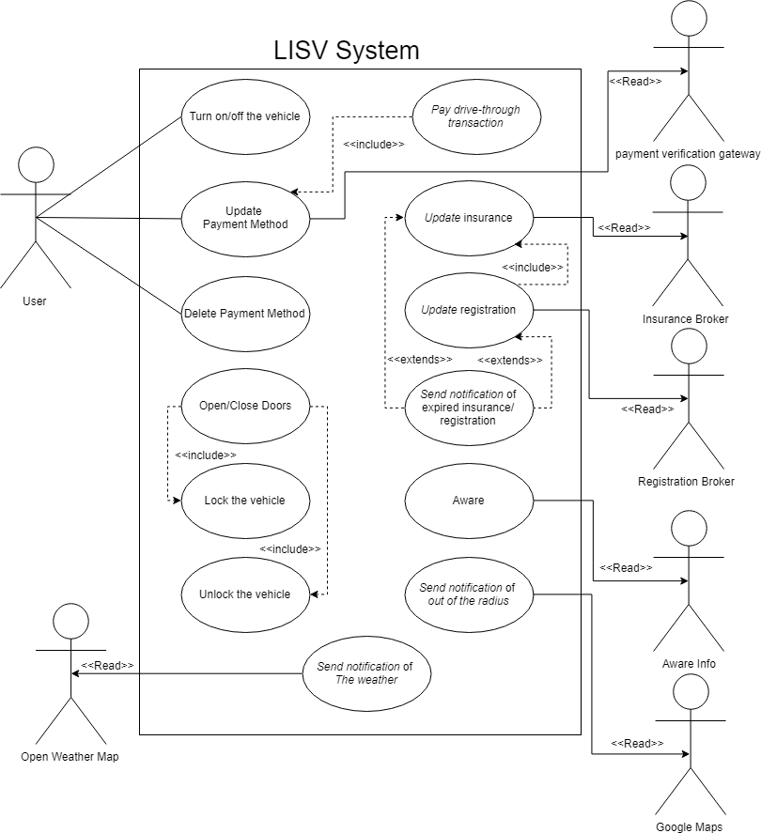
Figure 1: Use-Cases Diagram.

Use Case 1: Update insurance:

Table 1: Update insurance.
Use Case Name: Update insurance
Actor | Triggered by the System.
Secondary actor | The User.
Description | This use-case is for updating the insurance automatically and find the best price without user involvement.
Preconditions | The user updated his payment method.
Flow of events | - Send a notification to the user.  - User confirmation.  - Search the offers.  - Select the best offer.  - Select Expiration Date.  - Pay the insurance provider.
Postconditions | Insurance updated successfully.
Extends | Notification of expired vehicle insurance.

Use Case 2: Update registration:

Table 2: Update registration.
Use Case Name: Update registration
Actor | Triggered by the System.
Secondary actor | The User.
Description | This use-case is for updating the registration automatically without user involvement.
Preconditions | The user updated his payment method.  The user updated his insurance.
Flow of events | - Send a notification to the user.  - User confirmation.  - Select Expiration Date.  - Pay the registration fees.
Postconditions | Registration updated successfully.
Includes | Update insurance.
Extends | Notification of expired vehicle registration.

Use Case 3: Pay drive-through transaction:

Table 3: Pay drive-through transaction.
Use Case Name: Pay drive-through transaction
Actor | Triggered by the System.
Description | This use-case is for Paying drive-through by using “Near-field communication” chip if the vehicle enters the range of the payment device it makes the transaction.
Preconditions | The user updated his payment method.
Flow of events | - Vehicle enters the range of the payment device.  - Make the transaction.
Postconditions | The transaction done Successfully.

Use Case 4: Turn on/off vehicle:

Table 4: Turn on/off vehicle.
Use Case Name: Turn on/off vehicle
Actor | The user.
Description | This use-case is to set a time by the user to Turn on/off vehicle and at that time, it will turn on/off itself.
Flow of events | - Select to turn on or off.  - The user enters the time  - The system Turn on/off the vehicle at that time.
Postconditions | The vehicle Turned on/off.

Use Case 5: Send notification of out of the radius:

Table 5: Send notification of out of the radius.
Use Case Name: Send notification of out of the radius
Actor | Triggered by the system
Description | The system tracks the route of the vehicle using Google Maps and notifies the owner if the vehicle gets out of the radius of tracking by 1 km.
Preconditions | Vehicle is turned on
Flow of events | - The system gets routing information from Google Maps.  - The system tracks the route.  - The system checks that the vehicle is inside the radius.  - If the vehicle gets out of the radius by 1 km, the system sends a notification to the owner.
Postconditions | The notification sent to the user

Use Case 6: Update Payment method:

Table 6: Update Payment method.
Use Case Name: Update Payment method
Actor | User
Description | This use case describes how the user will add a new payment method or update an existing payment method, whether credit card or debit card. The user could add or update the payment method from the vehicle or from the application.
Preconditions | The user selects update payment method from the application.
Flow of events | - User selects update payment method from screen.  - The user chooses the payment method.  - The user enters card information  - The system saves the payment method.
Postconditions | The user has update payment method successfully.

Use Case 7: Aware:

Table 7: Aware.
Use Case Name: Aware
Actor | Triggered by System
Description | The system will send a notification to user letting user know about the nearest Workshop.
Preconditions | None
Flow of events | - System collect the information about the Workshops.  - System send a notification to user telling about the Workshop.
Postconditions | The user knows about the nearest Workshop.

Use Case 8: Weather:

Table 8: Weather.
Use Case Name: Weather
Actor | Triggered by System
Description | The system will send a notification to user letting user know about the weather.
Preconditions | None
Flow of events | - System collect the information about the weather.  - System send a notification to user telling about the weather.
Postconditions | The user knows about the weather.

Design Class:

Please note that full size of the diagram in the last Page.

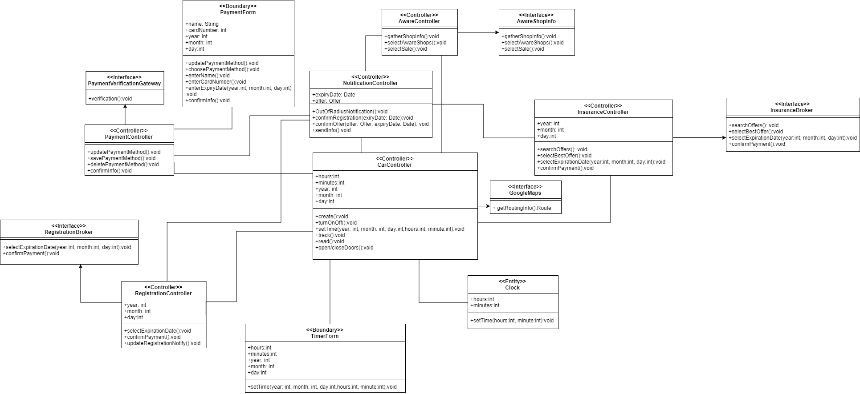
Figure 2: Class Diagram.

Sequence Diagram:

Sequence Diagram 1: Update insurance:

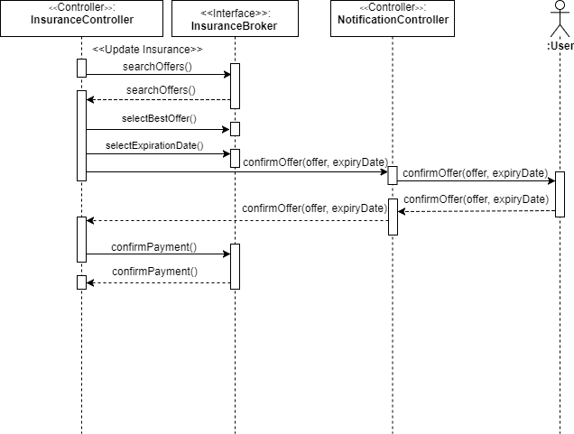
Figure 3: Update insurance.

Sequence Diagram 2: Update registration:

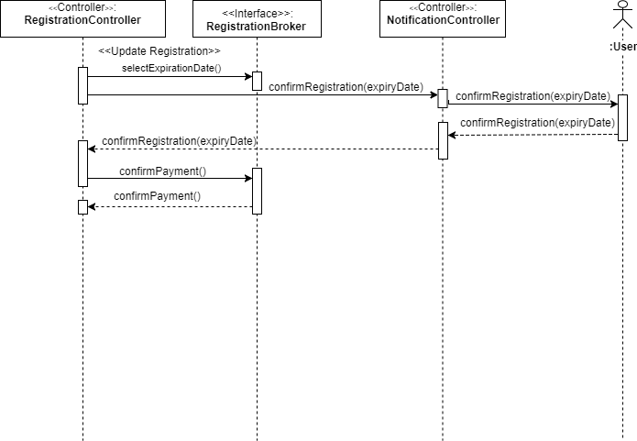
Figure 4: Update registration.

Sequence Diagram 3: Pay drive-through transaction:

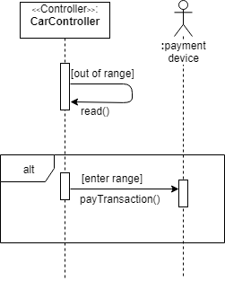
Figure 5: Pay drive-through transaction.

Sequence Diagram 4: Turn on/off vehicle:

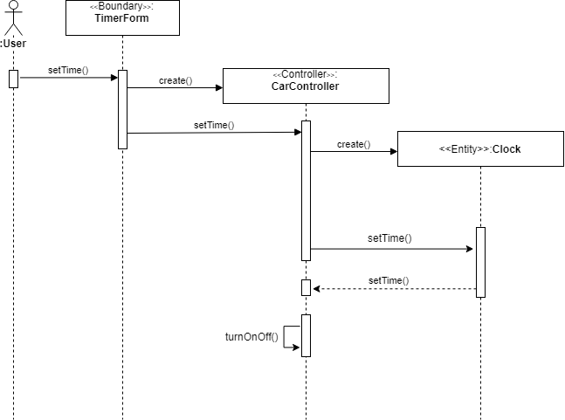
Figure 6: Turn on/off vehicle.

Sequence Diagram 5: Send notification of out of the radius:

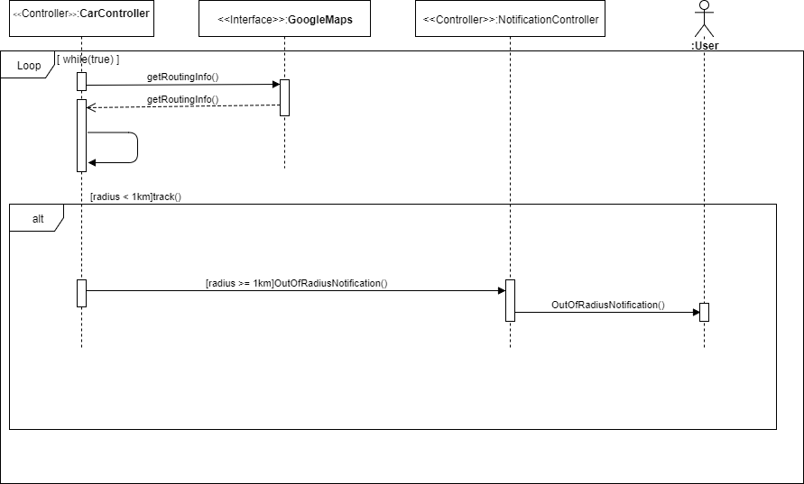
Figure 7: Send notification of out of the radius.

Sequence Diagram 6: Update Payment Method:

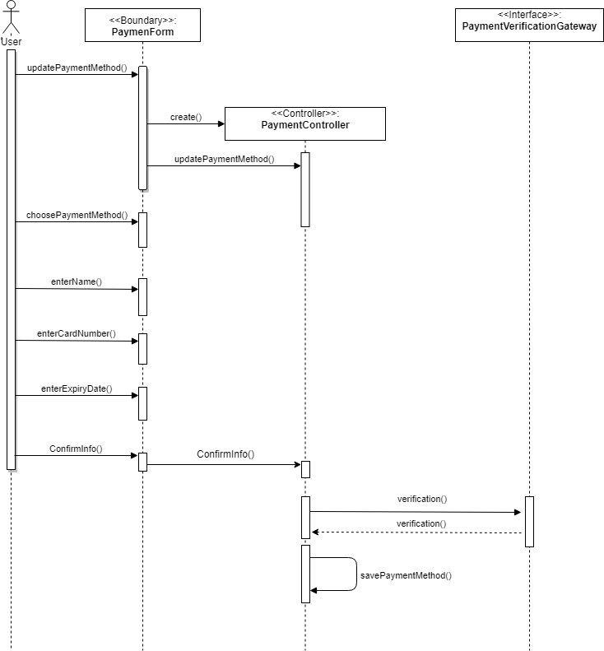
Figure 8: Update Payment Method.

Sequence Diagram 7: Aware:

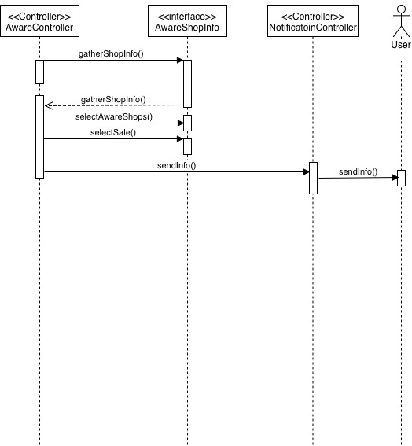

Figure 9: Aware.

System Architecture:

The system architecture for the system is Client-Server architecture, the user will be connected to the server, the device in the car will also be connected to the server as well, and the Database that we will implement is MySQL.

Prototype Description:

Implementation Platform:

The list below shows the hardware and the software technologies that were used to in to build our application:

- Visual Studio Code ‘Code Editor’ ^{[1]}.
- HTML.
- CSS.
- JavaScript.
- Laravel framework ^{[2]}.
- MySql.
- Sequel Pro ^{[3]}.
- Google Maps Api ^{[4]}.
- Open weather Api ^{[5]}.

Mapping between Requirements and Implemented Functions:

The following table shows a mapping between the projected functionalities of the system and the corresponding implemented modules.

Table 9: Mapping between Requirements and Implemented Functions.
Functional requirements | Modules/Functions/Class that implemented this feature
Update credit/ debit card information | addCard.blade.php, cards.blade.php
Delete credit/ debit card information
Turn on/off the vehicle | addTask.blade.php, tasks.blade.php
Lock/unlock the vehicle | addTask.blade.php, tasks.blade.php
Update vehicle insurance information | addInsurance.blade.php, companies.blade.php, insurance.blade.php, insuranceOffer.blade.php,
Update vehicle registration information | addRegistration.blade.php, carRegistration.blade.php
Notification for user alerting of near expired car insurance. | updateInsurance.blade.php
Notification for user alerting of near expired car registration. | updateRegistration.blade.php
Notification for user if the vehicle is out of the radius of tracking. | outofRadius.blade.php
Notification for user alerting user about nearest workshop. | awareofShops.blade.php
Notification for user alerting user about the weather. | weather.blade.php

Implementation Details:
This is some pieces of code for some of the functionalities of the system:

Table 10: Implementation Details.
Functionality | The piece of code
Notification for user alerting of near expired car insurance. | 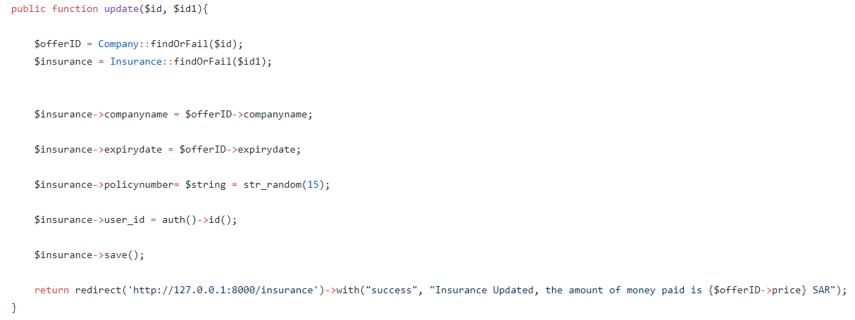
Notification for user alerting of near expired car registration. | 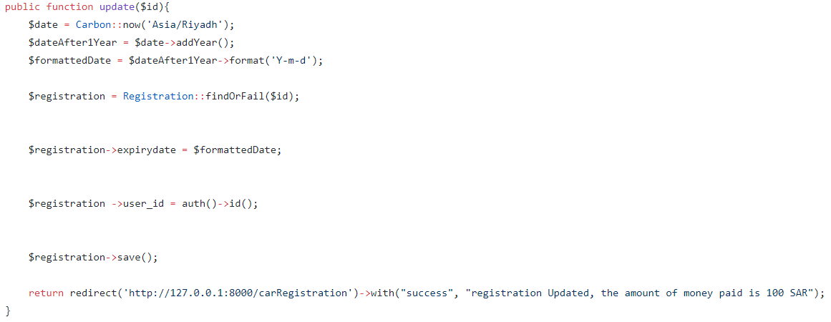
Notification for user if the vehicle is out of the radius of tracking. | 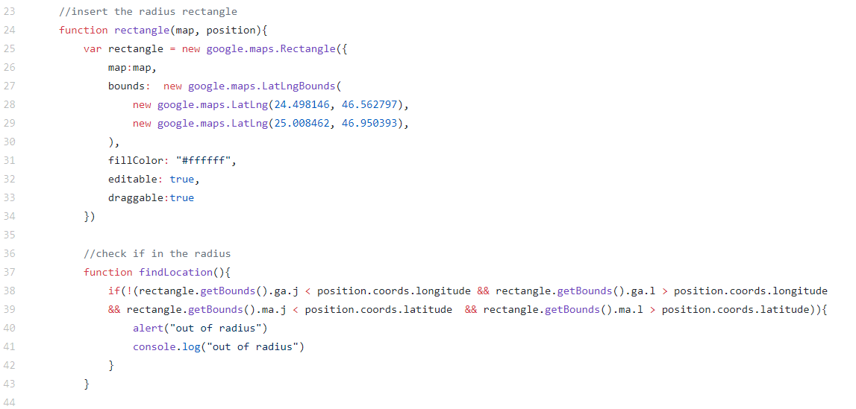
Notification for user alerting user about the weather. | 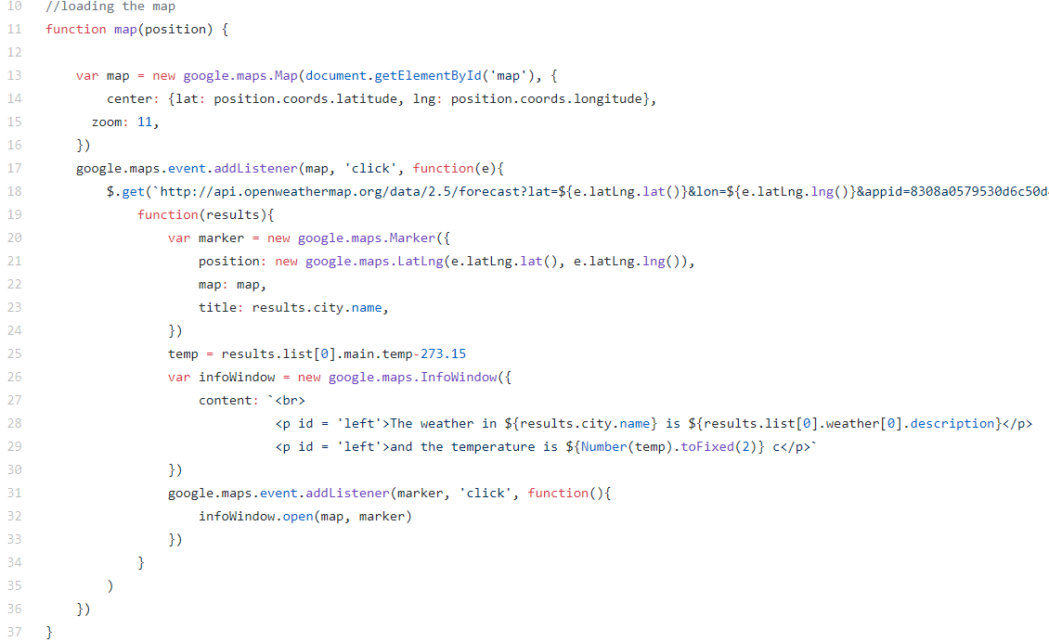

Actual Database:
The Actual Database Tables for the System:

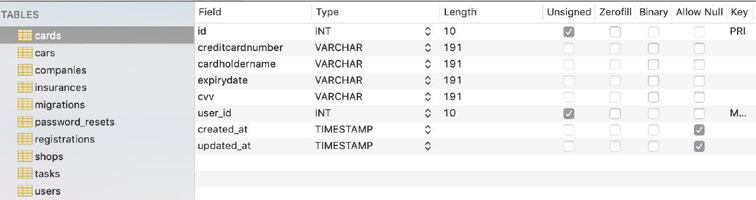
Figure 10: Database Cards Table.

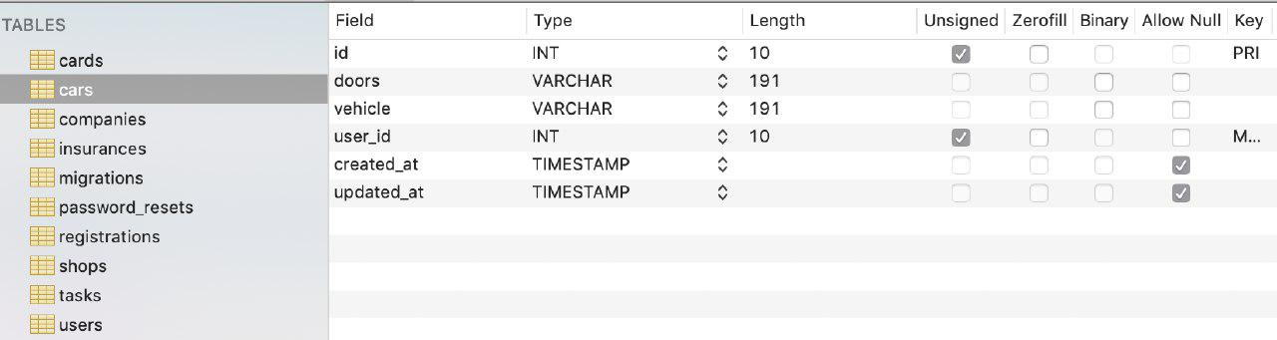
Figure 11: Database Cars Table.

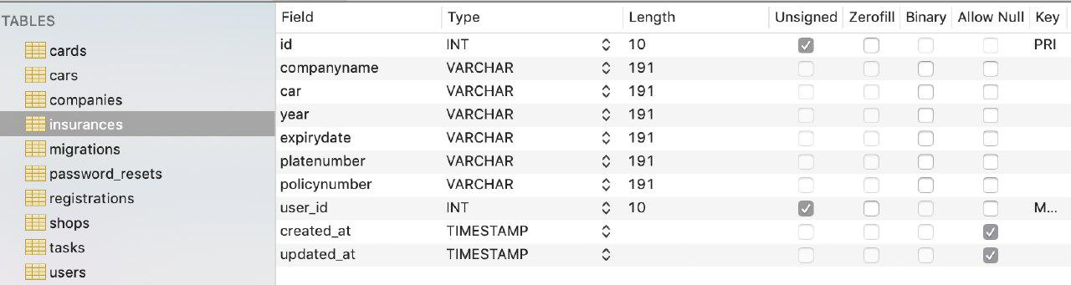
Figure 12: Database Insurances Table.

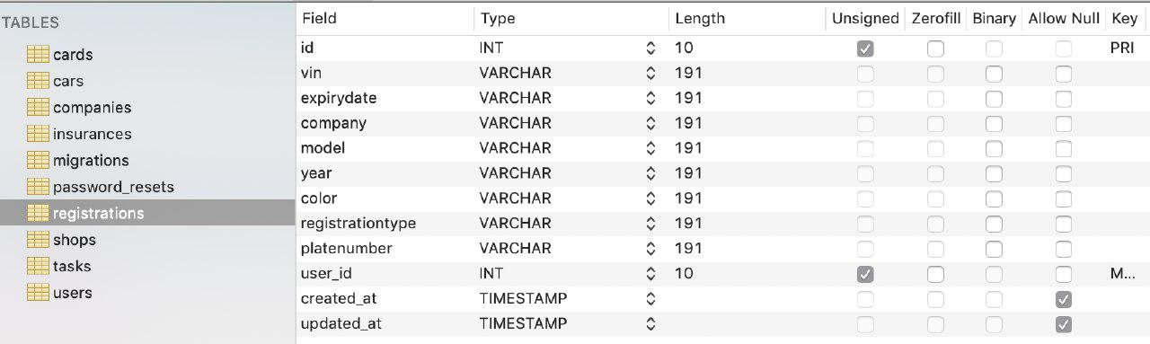
Figure 13: Database Registrations Table.

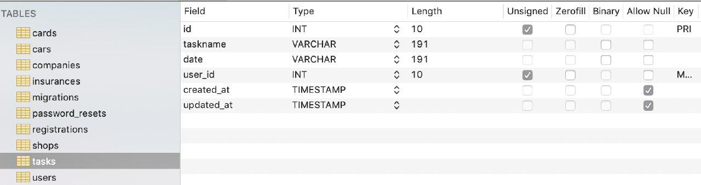
Figure 14: Database Tasks Table.

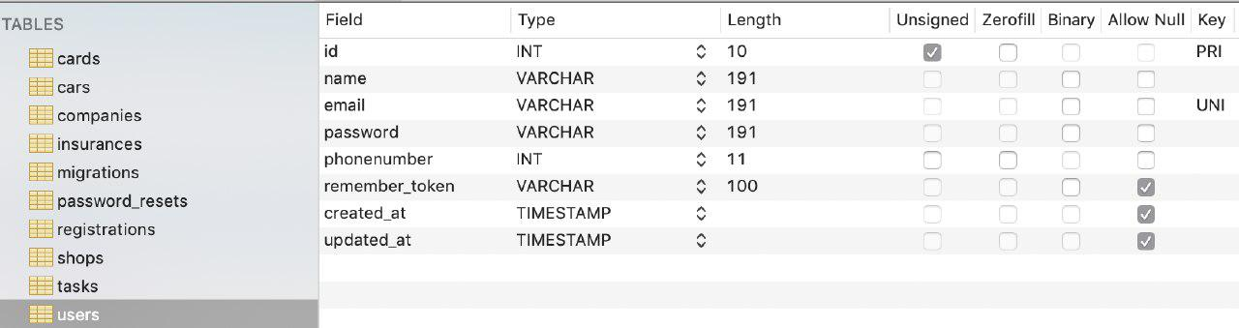
Figure 15: Database Users Table.

Testing:

We conducted several tests on the web application to make sure that the system functionality is working as meant to be. In this part of the document we list some test cases, unit tests, functional tests and usability testing.
We used the ‘’Postman ^{[6]}” and “Chrome DevTools ^{[7]}” Chrome DevTools is a set of web developer tools built directly into the Google Chrome browser. DevTools can help you edit pages on-the-fly and diagnose problems quickly, which ultimately helps you build better websites, faster.

Unit Test:
We tested various individual units in our application. Most of these units were tested manually with Chrome DevTools ^{[6]} due to time constraints, some units were tested in Postman ^{[6]}. The table below lists the units that were tested.
Table 11: Unit Test.
Function Name | Input | Expected Output | Actual Output | Test Result
Get The wither | Latitude & Longitude | The current wither | The current wither | Pass
Get nearest Workshop | Latitude & Longitude | Show the nearest workshop | Show the nearest workshop | Pass
Get Car Registration | - | Show Car Registration | Show Car Registration | Pass
Get Insurance Offer | - | Show the top 3 best Insurance Offers | Show the top 3 best Insurance Offers | Pass

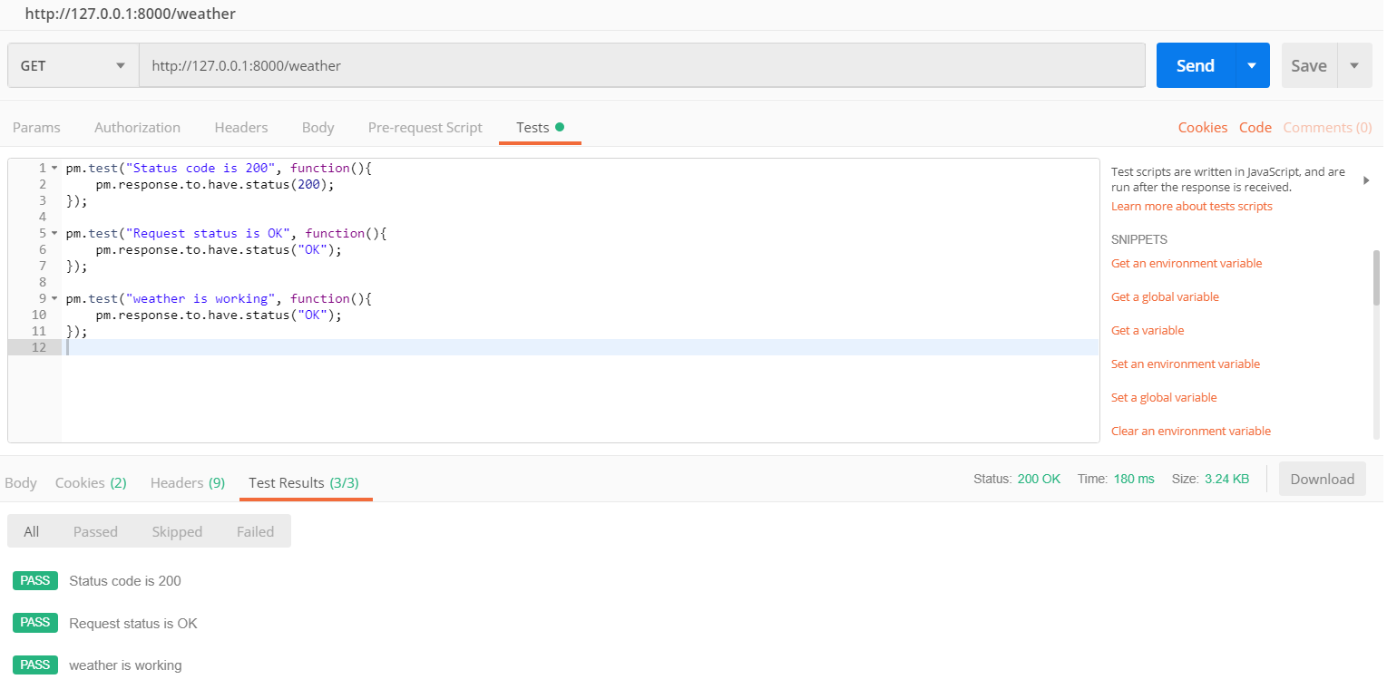
Figure 16: Wither.

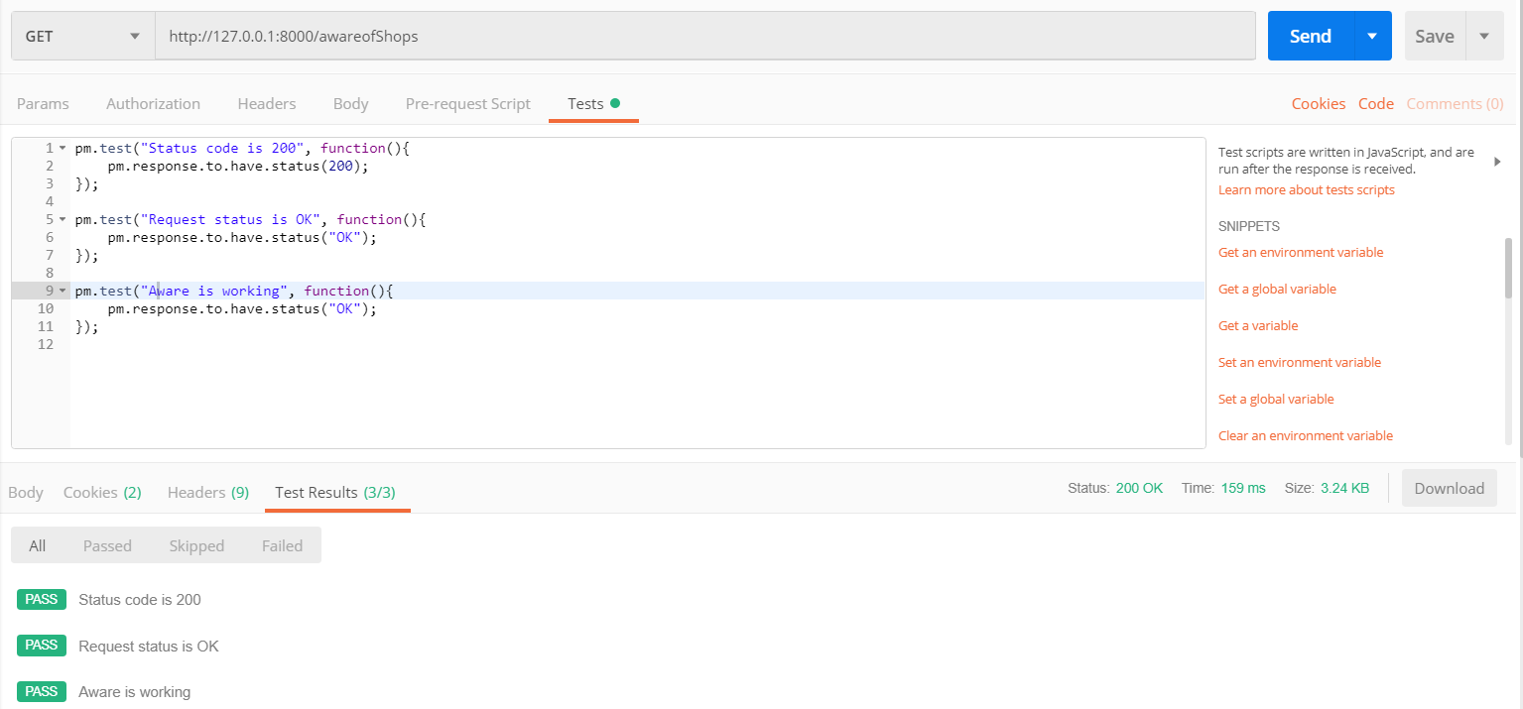
Figure 17:Aware.

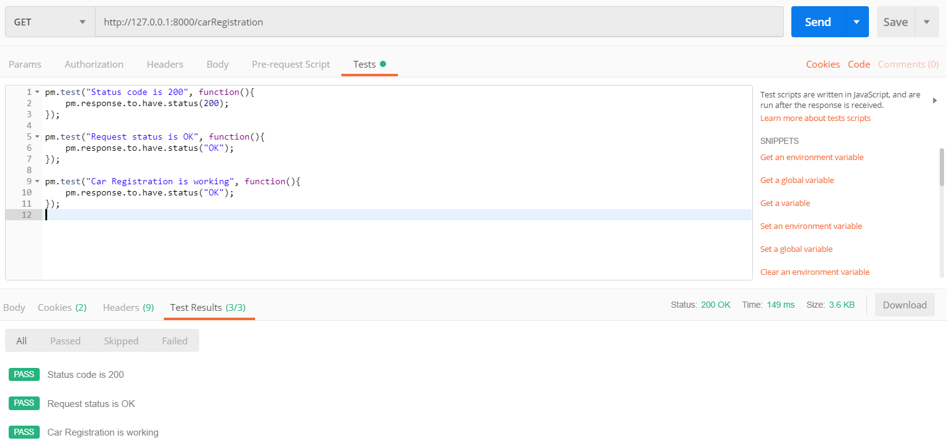
Figure 18: Car Registration.

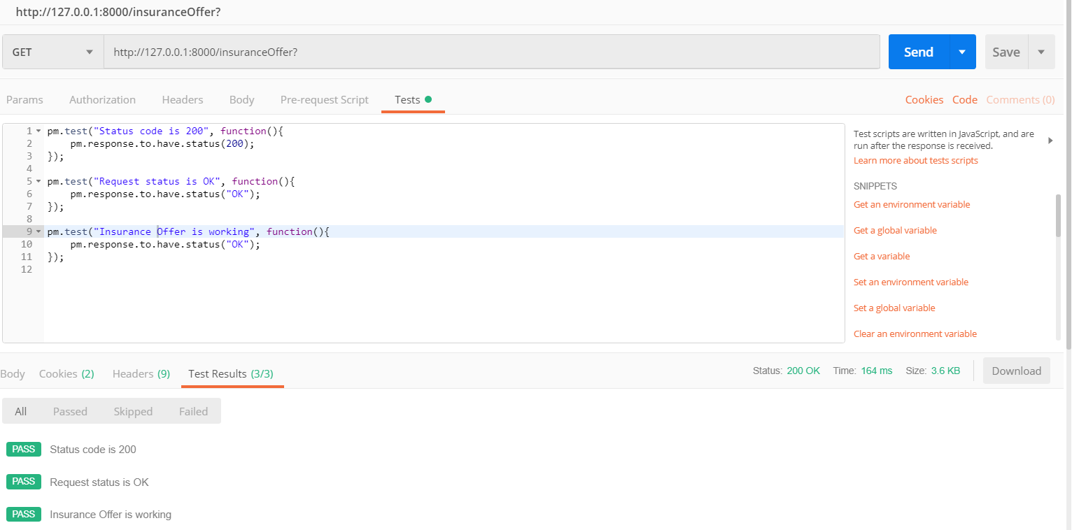
Figure 19: Insurance Offer.

Functional Test:

These are some samples of the test cases that used to test the functionality of the system.

Table 12: Test Cases.
Test Case name | Scenario | Input | Expected Output | Actual Output | Test Status
Update Payment Method | User enters payment information correctly | Payment method  Name  Card number  Expiry date | Payment method saved | As Expected | Pass
Update Payment Method | User enters wrong card number. | Payment method  Name  Wrong Card number  Expiry date | Payment method declined | As Expected | Pass
Send notification of out of the radius | Vehicle gets routing information from google maps | Routing Information | Out of radius notification | As Expected | Pass
Send notification of out of the radius | Error connecting to the internet and getting routing information | No Routing Information | Error getting routing information | As Expected | Pass
Turn on/off vehicle | User sets time for turning on/off the vehicle | Hour  Minute  Second | Time is set. | As Expected | Pass
Turn on/off vehicle | User enters wrong time format | Hour = 25  Minute  Second | Hour cannot be more than 25 | As Expected | Pass
Update registration | Registration controller selects expiration date and asks the user to confirm information | Day  Month  Year | Information confirmed  Payment confirmed | As Expected | Pass
Update registration | Error during asking the user for confirmation | Day  Month  Year | Information is not confirmed | As Expected | Pass
Update Insurance | Insurance controller searches for offers, selects the best offer, insurance expiration date and ask the user to confirm the offer | Best offer  Day  Month  Year | Information confirmed  Payment confirmed | As Expected | Pass
Update Insurance | Error while searching for offers | - | No offer confirmation | As Expected | Pass

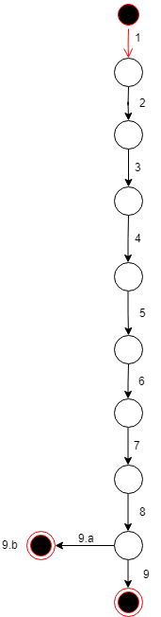
Branch Coverage Testing:

Function to be tested: add Car Registration

Actors: User

Precondition: User is logged in

Steps:
- User enters a VIN
- User enters Expiry Date
- User enters Company
- User enters Model
- User enters Year
- User enters Color
- User enters Registration Type
- User enters Plate Number
- User click Add Registration

Post condition: User add Car Registration

Alternative steps:
9.a empty field
9.b system shows alert message

Figure 20: Branch Coverage.
ID | Events | Description
1 | 1-2-3-4-5-6-7-8-9 | This is the basic scenario; the registration will be added
2 | 1-2-3-4-5-6-7-8-9-9a-9b | When the user leaves an empty filed and click add registration

Usability Test:
We let 5 of our colleagues trays our system and after they used it we send them a Google Forms link, and this is the result:

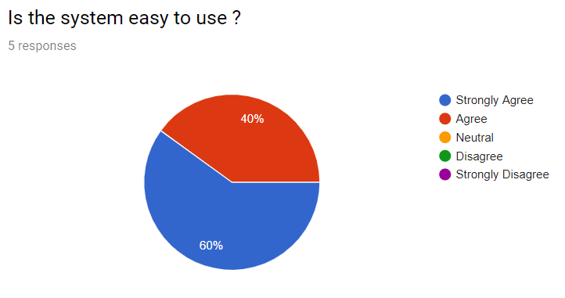
Figure 21: Usability survey 1.

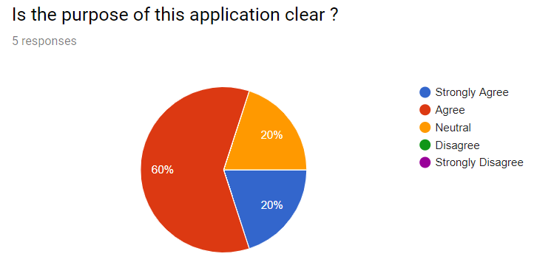
Figure 22: Usability survey 2.

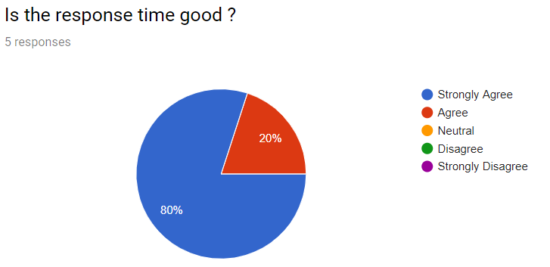
Figure 23: Usability survey 3.

Deployment of the System:

The user sends request through the application, the application sends this request to the web server, the web server makes operations over the request, and retrieve some data from the car devise, after that the web server sends the result to the user application.

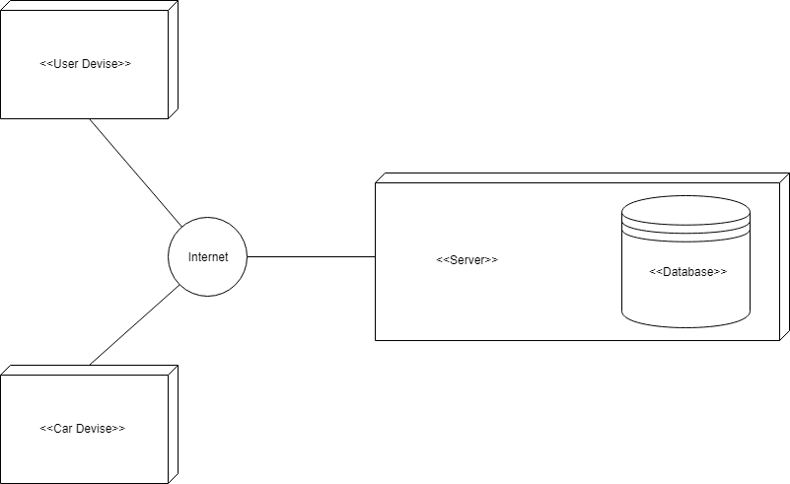
Figure 24: Deployment diagram.

Limitation of the System:

This project is developed as a requirement for graduation in Software Engineering, and because of Lack of time, Lack of experience and no budget are the biggest challenges to build this project.

We could not implement the Pay drive throw functionality.
We did not find the appropriate APIs to some of our system functionalities.

Conclusion and Future Work:

At the end of this phase we have learned a lot through all the troubles we've met and every challenge we've faced,
we developed our application from analysis phase to implementing phase.
we couldn’t achieve some of the planned objectives and functionalities, but we designed, implemented and tested the main features of the system.

Future work:

- Build an Android and IOS applications.
- Implement the pay drive throw functionality.
- Getting a better back-end server.
- Develop a website to market and showcase the product.
- Enhance the GUI in the applications.

Reference:

- https://code.visualstudio.com/ [4/7/2019].
- https://laravel.com/ [4/7/2019].
- https://www.sequelpro.com/ [4/7/2019].
- https://cloud.google.com/maps-platform/?hl=en [4/7/2019].
- https://openweathermap.org/api [4/7/2019].
- https://www.getpostman.com/ [4/7/2019].
- https://developers.google.com/web/tools/chrome-devtools/ [4/7/2019].

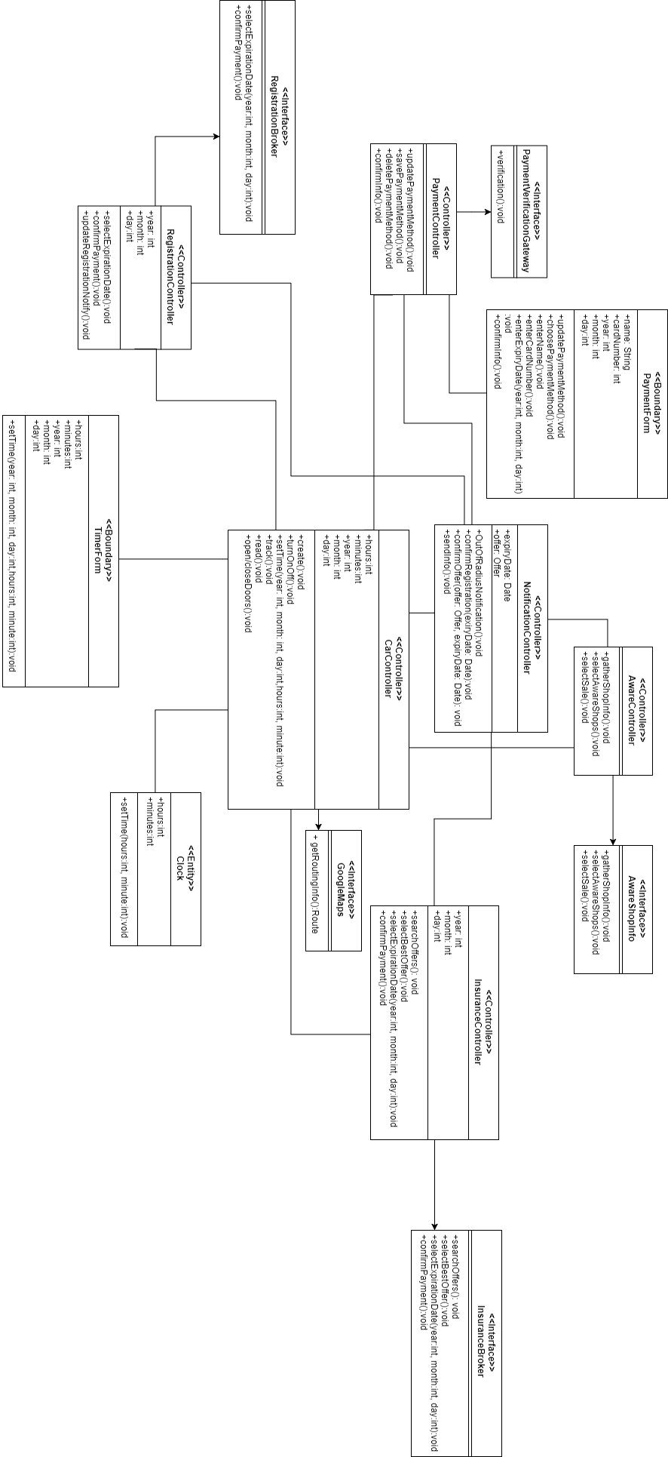
Figure 25: Full size Class Diagram

